**Annotations In Hibernate Explained**

* To make this class persistent using annotations, we first define it as *Entity.* We do so by annotating the class with the @*Entity* annotation.

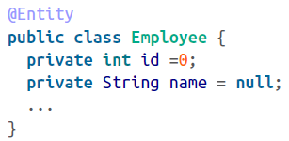

* We have to use the @Table annotation to tell hibernate which object to map with which Table:

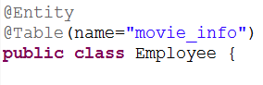

* Now that we have a persistent entity, our next step is to define an identifier. Remember, all persistent entities must have their identifiers defined; otherwise, Hibernate will complain.

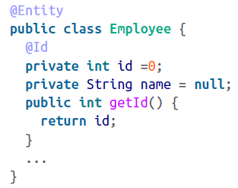

* If we only use @id annotation then the column name should match the variable name, We can also set a different column name, for example:

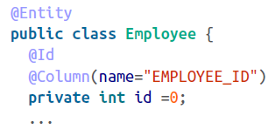

* We must let the Hibernate configuration know about annotated classes. Declare it in your cfg file.
* In your hibernate.cfg.xml file, use the mapping element to declare your class. Here’s how we do it via the mapping file:

